Graduate School of Social Welfare
Ewha Womans University
Student Portfolio

Name | Student No. | Enrollment
E-mail | Phone Number | Professor

* This Portfolio is written by both student and professor to check the process of the student’s thesis, monitor achievements and promote self-development.

- You should submit your portfolio until the end of every semester (3rd week of June and December).
- You should submit your portfolio with your professor’s signature to BK assistant in each Professor’s office. She will upload every student’s portfolio in DROPBOX every semester. Also you should keep an original one. When you graduate, the final portfolio should be made.

Study Plan
* You need to write down what lesson you want to learn and which classes you want to attend. And you should write including specific, general thesis plan, and major practice or expected seminars (*Write only once at the 1st semester.)
Self – design Curriculum: write about your curriculum related to Ewha University’s curriculum or other University’s Curriculum . *The next table will be helpful (Refer to the Curriculum table. Write only once at the 1st semester as long as your plan is not changed)
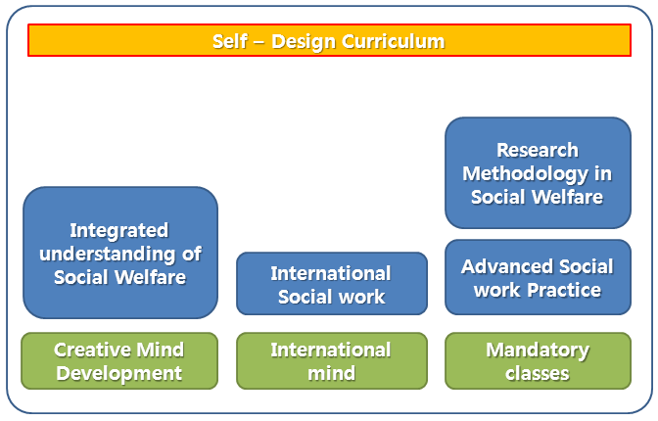

Career plan: write about your career goal and plan after graduation. (*write at the 1st semester and the last semester)
Self – evaluation of attended classes, seminars and experience during this semester
Plan for the next semester: write about which lecture you will take and plan for studies
Professor's report: Overall evaluation of the student's life and study during the semester.

Date :

Student’s Name : ___________________

Professor’s Name : ___________________

